P



Computer Networks Lab (CSE 2106)

Final Documentation

This is final documentation for the Airport Management Networking System using Cisco Packet tracer for the Computer Networks Lab. This project consists of usage of various Protocols and end devices showing an elaborate designing or brief of how an airport networking works.

**PROJECT NAME:**

**AIRPORT MANAGEMENT NETWORKING SYSTEM**

**Submitted by:**

**Submitted to:**

**Project Title:**

Design and Implementation of an Integrated Airport Management Networking System Using Cisco Infrastructure

**Project Overview:**

This project aims to design and implement a comprehensive networking system for airport management. The system will streamline communication, data flow, and security among various airport departments, such as Air Traffic Control (ATC), Baggage Handling, Customs, Airlines Office, and Emergency Facilities. By leveraging Cisco routers, switches, and protocols like VLAN, OSPF, and DHCP, this project will ensure seamless, secure, and reliable operations across the airport's various segments.

**Problem Statement:**

Airports face challenges like inefficient communication between departments, network congestion, security risks, limited scalability & flexibility and inconsistent IP configurations. This project addresses these issues by creating a scalable, segmented network using VLANs, OSPF, and DHCP to enhance efficiency, security, and performance across various airport departments.

Airport Management Networking System

Utilities:

* Server
* Computers/PC
* Routers
* Switch
* Wires
* IP Phone

Used Protocols and process:

* DHCP
* OSPF
* VLAN
* IP Configuration
* Server Configuration
* VoIP
* RIP

Segments:

* ATC- Air Traffic Control

and Flight Dispatch

* Baggage and Cargo Handling portion
* Customs and Immigration
* Airlines Office
* Ground operation Control room
* Emergency and medical Facilities
* Data Center and IT

**Airport Management Networking System**

Documentation

**Project Objectives:**

**Design and Implement a Scalable Network Architecture:**

Segment the network into different VLANs for departments such as ATC, Baggage Handling, Customs, Airlines Office, and Emergency Facilities.

**Establish Efficient Routing:**

Use OSPF (Open Shortest Path First) protocol to ensure dynamic and reliable routing between various VLANs.

**Automate IP Address Allocation:**

Configure a DHCP server for automatic IP address distribution to all devices across departments.

**Ensure Network Security and Traffic Optimization:**

Implement access control lists (ACLs) and firewall configurations to secure inter-department communication.

Optimize network performance through proper switch and router configurations.

Proposed Solution:

The project will utilize Cisco Packet Tracer for network simulation and testing. The following steps outline the solution:

**Network Design:**

Segmentation using VLANs: Each department (e.g., ATC, Customs, Airlines) will have its own VLAN to ensure traffic isolation and improve performance.

* **Inter-VLAN Routing:** Use a Router-on-a-stick configuration to allow communication between VLANs using sub-interfaces on a central router.
* **Routing Protocol (OSPF):** Implement OSPF to handle dynamic routing between different VLANs and ensure optimal path selection.
* **DHCP Configuration:** Set up DHCP servers in the IT/Data Center segment to automatically assign IP addresses to each VLAN, reducing configuration errors and simplifying network management.
* **Switch Configuration:** Cisco switches will be used to connect devices within each VLAN and ensure intra-VLAN communication.
* **Security and Monitoring:** Implement security features such as ACLs, VLAN access control, and continuous network monitoring for potential threats.
* **Vo-IP Configuration:** VoIP can be used in an airport management network for communication between departments such as ATC, ground operations, emergency services, and airlines.
* **RIP:** which is a routing protocol that Cisco uses to share information between routers on local area networks.

**Network Segmentation Plan:**

**Under Cloud:**

|  |  |  |
| --- | --- | --- |
| **Segment** | **IP network** | **Device** |
| Central Cloud Server | 20.0.0.0 | Server |

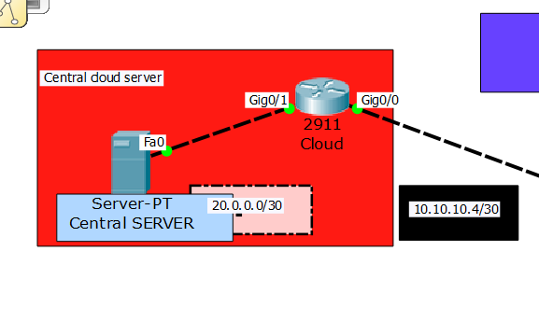

**Under Runway pitch and Landing Spot:**

|  |  |  |
| --- | --- | --- |
| **Segment** | **Routing Protocols** | **IP network** |
| Runway | Static | 192.168.8.0 |
|  | RIP | 192.168.13.0 |
| Landing Spot | OSPF | 192.168.9.0 |
|  | OSPF | 192.168.10.0 |
|  | OSPF | 192.168.11.0 |
|  | OSPF | 192.168.12.0 |

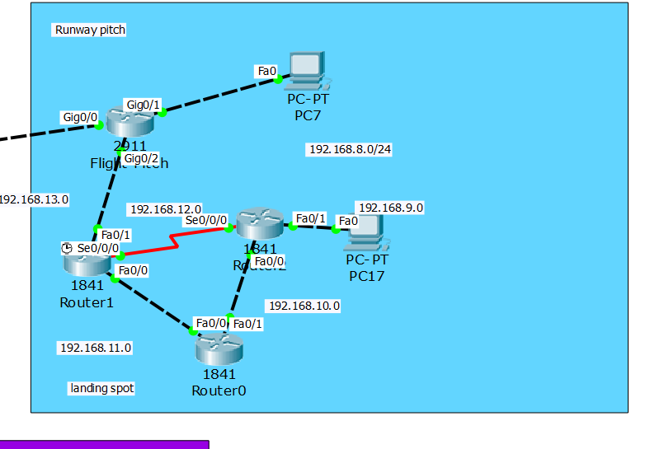

**Under Main Switch of Terminal 1:**

|  |  |  |
| --- | --- | --- |
| **Segment** | **VLAN ID** | **IP Range** |
| Air Traffic Control (ATC) | 10 | 192.168.1.0/24 |
| Baggage and Cargo Handling | 20 | 192.168.2.0/24 |
| Customs and Immigration | 30 | 192.168.3.0/24 |
| Airlines Office | 40 | 192.168.4.0/24 |
| Ground Operations Control Room | 50 | 192.168.5.0/24 |
| Emergency and Medical Facilities | 60 | 192.168.6.0/24 |
| Data Center and IT | 70 | 192.168.7.0/24 |
| **Protocols used** | DHCP, VLAN using Switch, VoIP | |

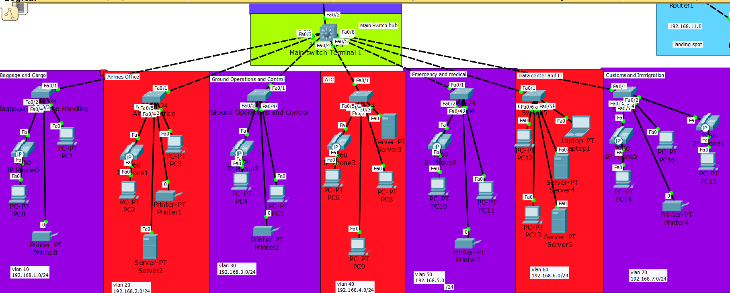

**Network Design:**

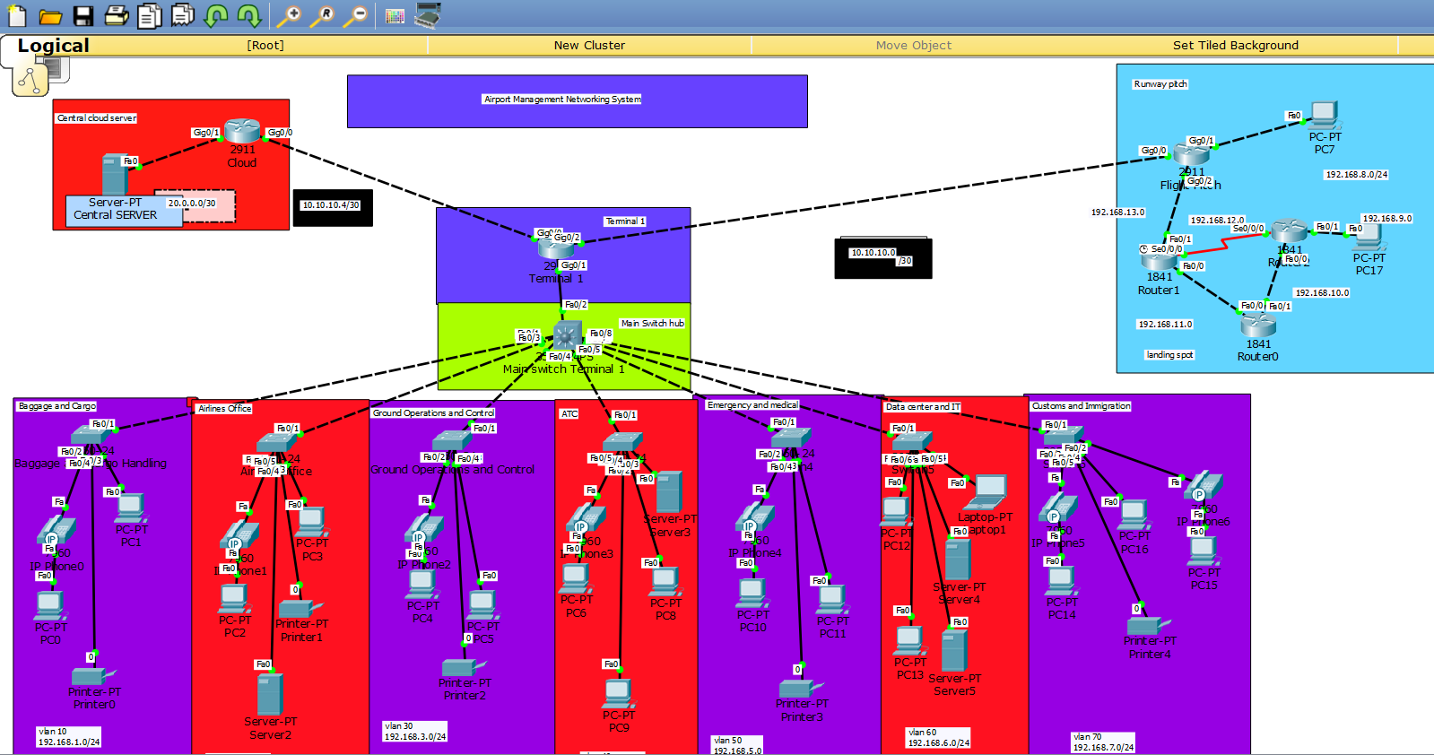

**VLAN Routing:**

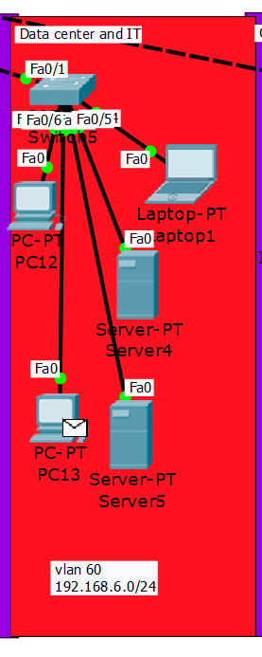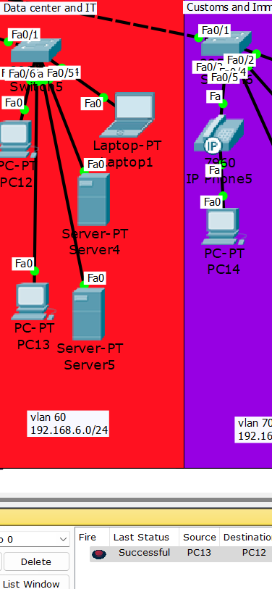

**DHCP:**

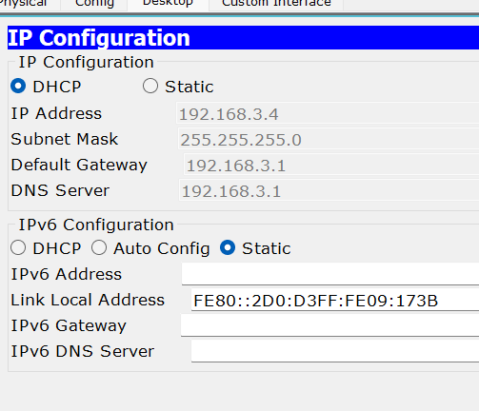

**VoIP Working:**

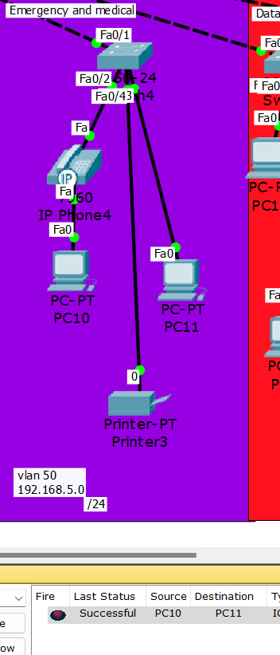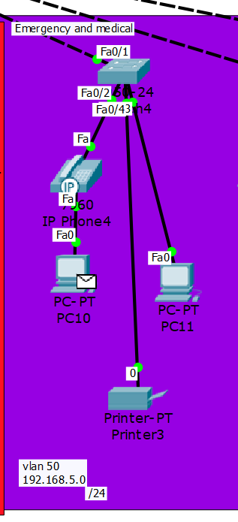

**Server to cloud:  
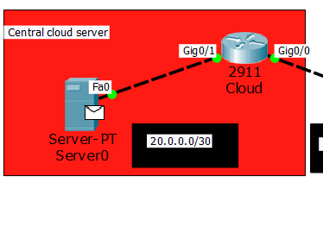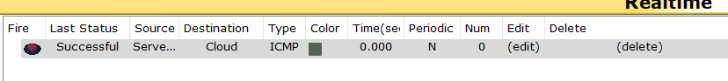**

**OSPF:**

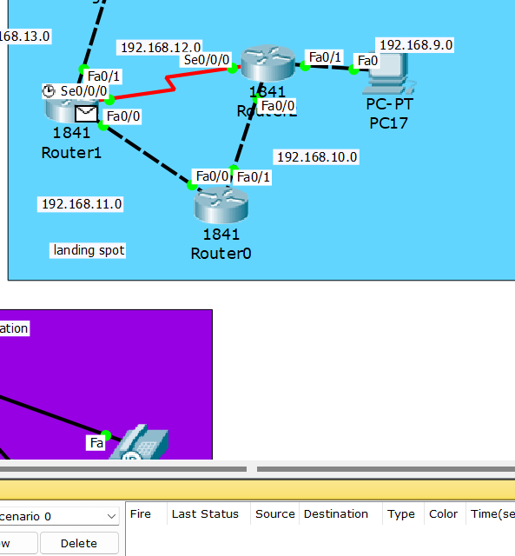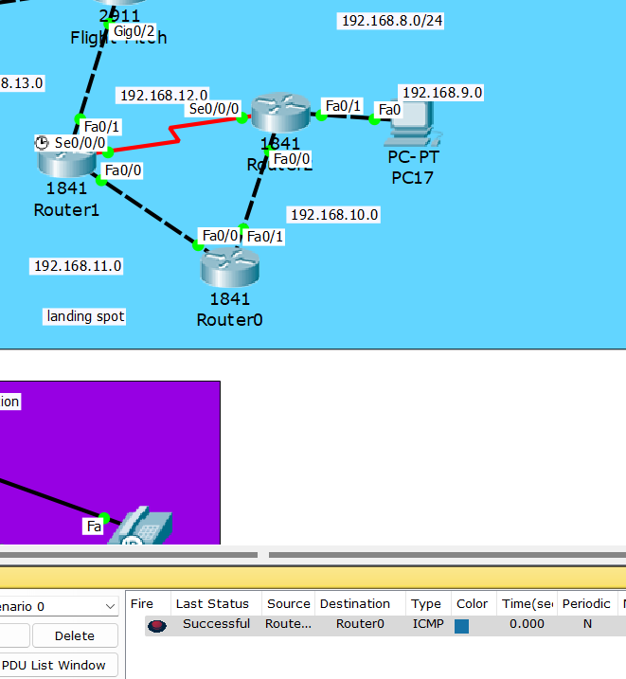

**RIP:**

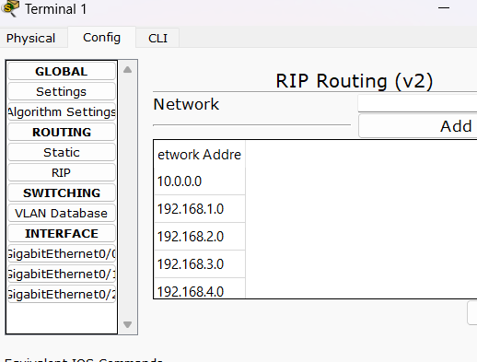

**Outcomes:**

* A fully functional, scalable, and secure airport management network.
* Improved communication between critical departments, ensuring smoother airport operations.
* Simplified network management and troubleshooting through automation and segmentation.
* Enhanced network security through isolated VLANs and controlled routing.